Loading data from Excel sheet to database

This document is connected to Excel sheet “Example to load.xlsx” to be found in same directory.

1. Fill the excel Sheet:



1. Copy paste the data in the first tbl_person section to the tbl_person.csv and store it in another directory, do not forget to leave first column empty



1. Store a number in the first column, higher than highest number in database for this field

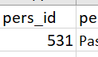

1. Extract next part of Excel sheet for tbl_residence into tbl_residence.csv leave again last id column empty, store it into same directory as before





1. Fill the id number column as before with same number

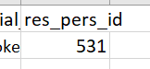

1. Extract next part of Excel sheet for tbl_elc_struc1 and fill it to tbl_elc_struc1.csv leave the id column empty





1. Fill the id number column as before with same number, do not forge to store it same new directory not to corrupt template

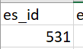

1. Extract next part of Excel sheet for tbl_residence and fill it to tbl_residence.csv leave the id column empty





1. Fill the id number column as before with same number

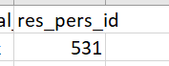

1. Extract next part of Excel sheet for tbl_banking and fill it to tbl_banking.csv leave the id column empty





1. Fill the id number column as before with same number



1. Extract next part of Excel sheet for tbl_emergency_contact and fill it to tbl_emergency_contact.csv leave the id column empty





1. Fill the id number column as before with same number

